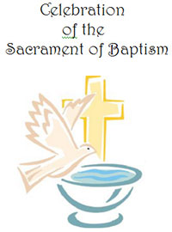
Parish Guidelines/Standards for the Rite of Infant Baptism

- A parent or guardian must request baptism for their child.
- Both parents must attend the baptismal preparation class.
- There must be a founded hope that the child being baptized will be brought up in the Catholic religion.
- Godparents must attend a Baptismal preparation class, either here at Holy Spirit or through another church.

- A godparent must be a confirmed, practicing Catholic in good standing with the Church. If they are married, they must be married in the Catholic Church. You can have two godparents, one male and one female. A non-Catholic may stand up with the parents at the Baptism, but their name will not appear on the certificate. They will be considered a “Christian Witness”.

- Children are encouraged to come dressed in a white garment to the baptismal ceremony.
- A special Baptismal candle will be furnished by the parish to the family of each child.
- Baptisms take place in the parish church.

Scheduling the Rite of Baptism

After completion of the baptism preparation class by the parents, please contact the parish office and arrange the date and time for the baptism of their child. These dates have been prescheduled on the parish calendar. The following are general guidelines for the scheduling of an infant baptism.

- Baptisms are usually scheduled at 10:00am on Saturdays.
- Father/Deacon will not completely immerse the infant into the church baptismal font unless arranged specifically by the parents prior to the ceremony. Water from the font will be poured over the head of the infant or child.
- An official Certificate of Baptism will be provided to the parents after the ceremony.
- Parents may make a suggested donation of $50.00 to the parish office prior to their child’s baptism.

Baptism Guidelines Revised 05.10.2022

